*Caedes Lupi*

**Team Name:** The Alpacas

**Team Members:** Nick Engell, Kevin Dolan, Owen King, Tucker Burke, Joseph Hong

**Basic Premise:** Play as the only werewolf detective in Chicago and stop an order of evil werewolves from killing thousands in a vile ritual.

**Win Condition:** Infiltrate a cabal of werewolves planning to enact a dark ritual after committing an act of mass carnage.

**Obstacles to Winning:** Dangerous, patrolling werewolves, either in human form or wolf form, and platforming hazards such as magical traps.

**Specifications:** The game will be a single player action/stealth-platformer game for PC, built in the Unity game engine.

**Gameplay/Flow:** The game will have a snappy action platformer flow, with enemies who must be dealt with quickly or will quickly deal with the player. The player must use stealth to avoid or dispatch enemies to progress.

**Mechanics/Rules:** Stealth, avoiding enemies, simple puzzles in human form, transforming into wolf form to pounce on enemies from behind.

**Images/References:**

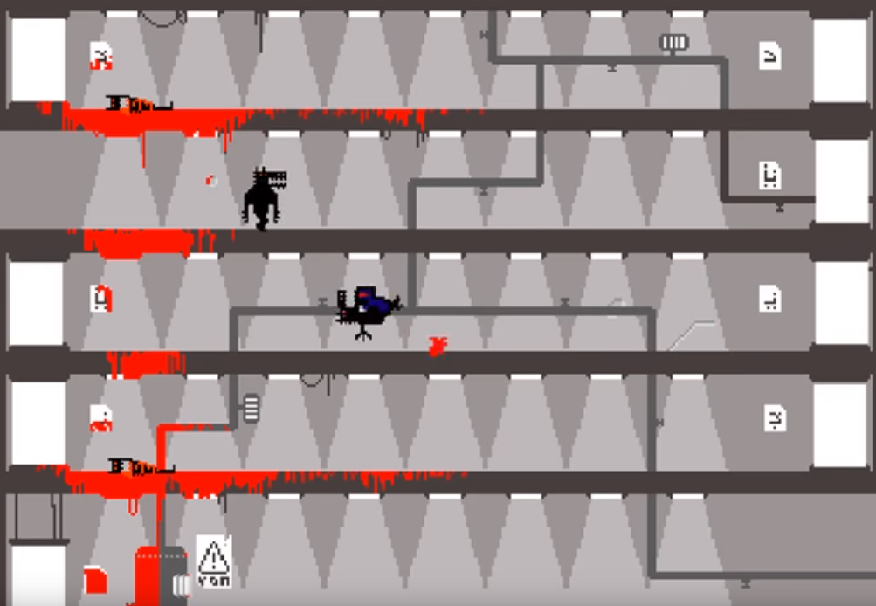

**Vox Populi Vox Dei**, a platformer where the player sneaks and fights their way through a stronghold filled with werewolves to rescue their girlfriend. The aesthetic and the gameplay style of our game will look similar to this game.

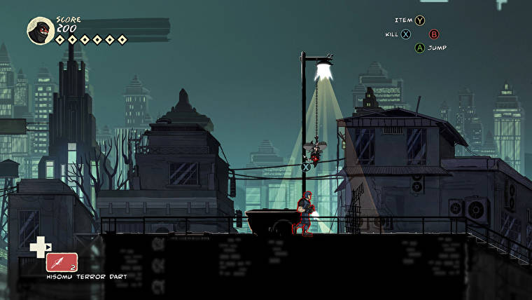

**Mark of the Ninja**, a stealth action platform where the player plays as a ninja in the modern world trying to save his ninja order from destruction by a power hungry company by stealing from and assassinating key members of said company.

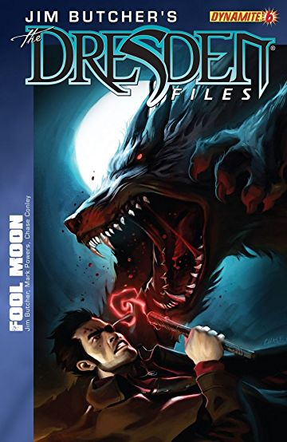

Another source from Dresden Files: Fool Moon with an image that shows how big and powerful the other werewolves (enemies) can be when getting caught directly as a human.

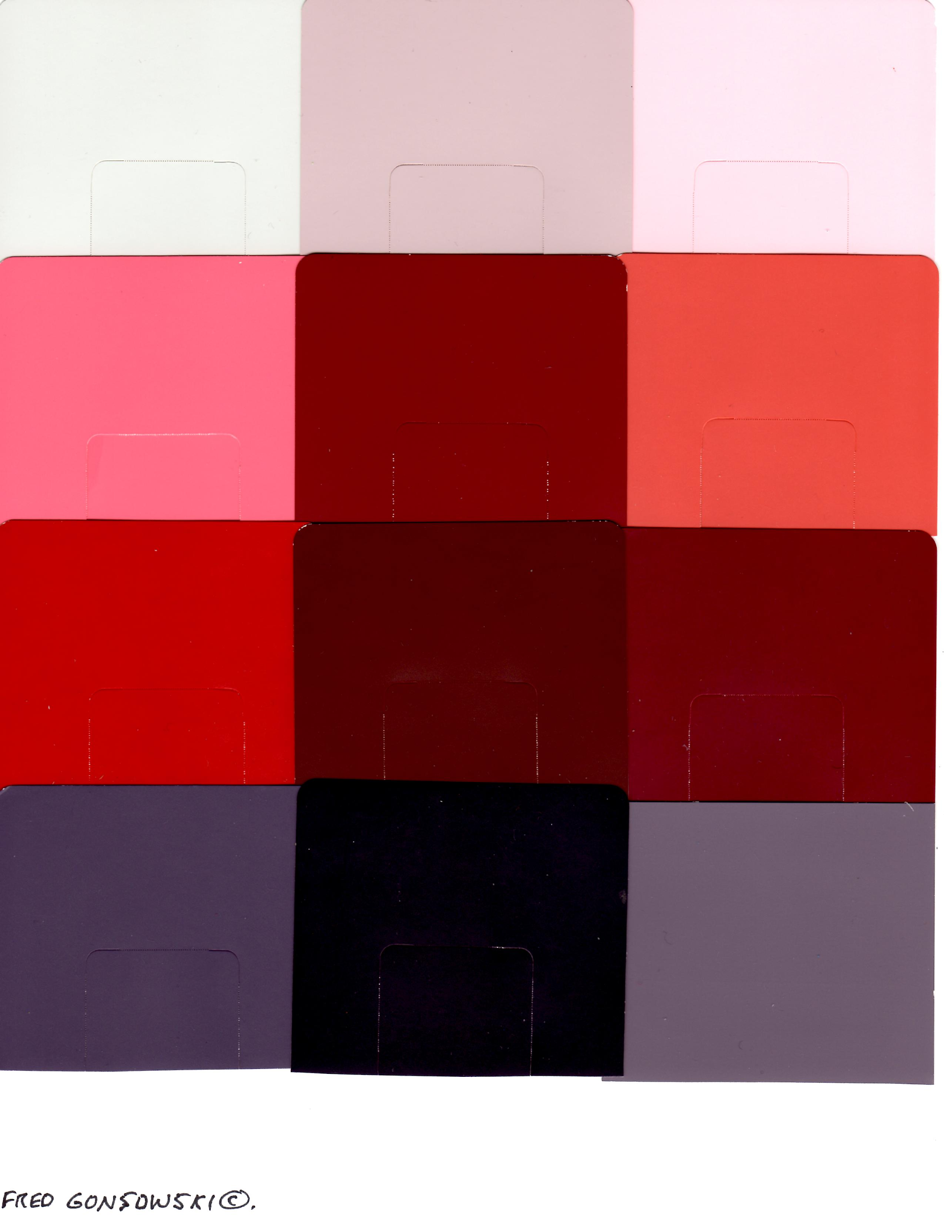

Potential color palette for the game. Not a lot of bright colors except the ones that is connected to red. The mood for this game is more towards of depressing and hopeless.

**Concept Art:**

Here are a few concepts experimenting with the selected color palette. Attempting to execute the **Vox Populi Vox Dei** style in a more illustrated manner yielded a result similar to that of **Limbo**. You can see our protagonist, in dire form, making its way through the scene. You get a pretty good sense of scale.

